Tss-rsa

====================================

protoc buf使用指定的版本[注意不要使用brew的默认版本，大概率和代码的编译不兼容]

<https://github.com/protocolbuffers/protobuf/releases/tag/v3.20.0>

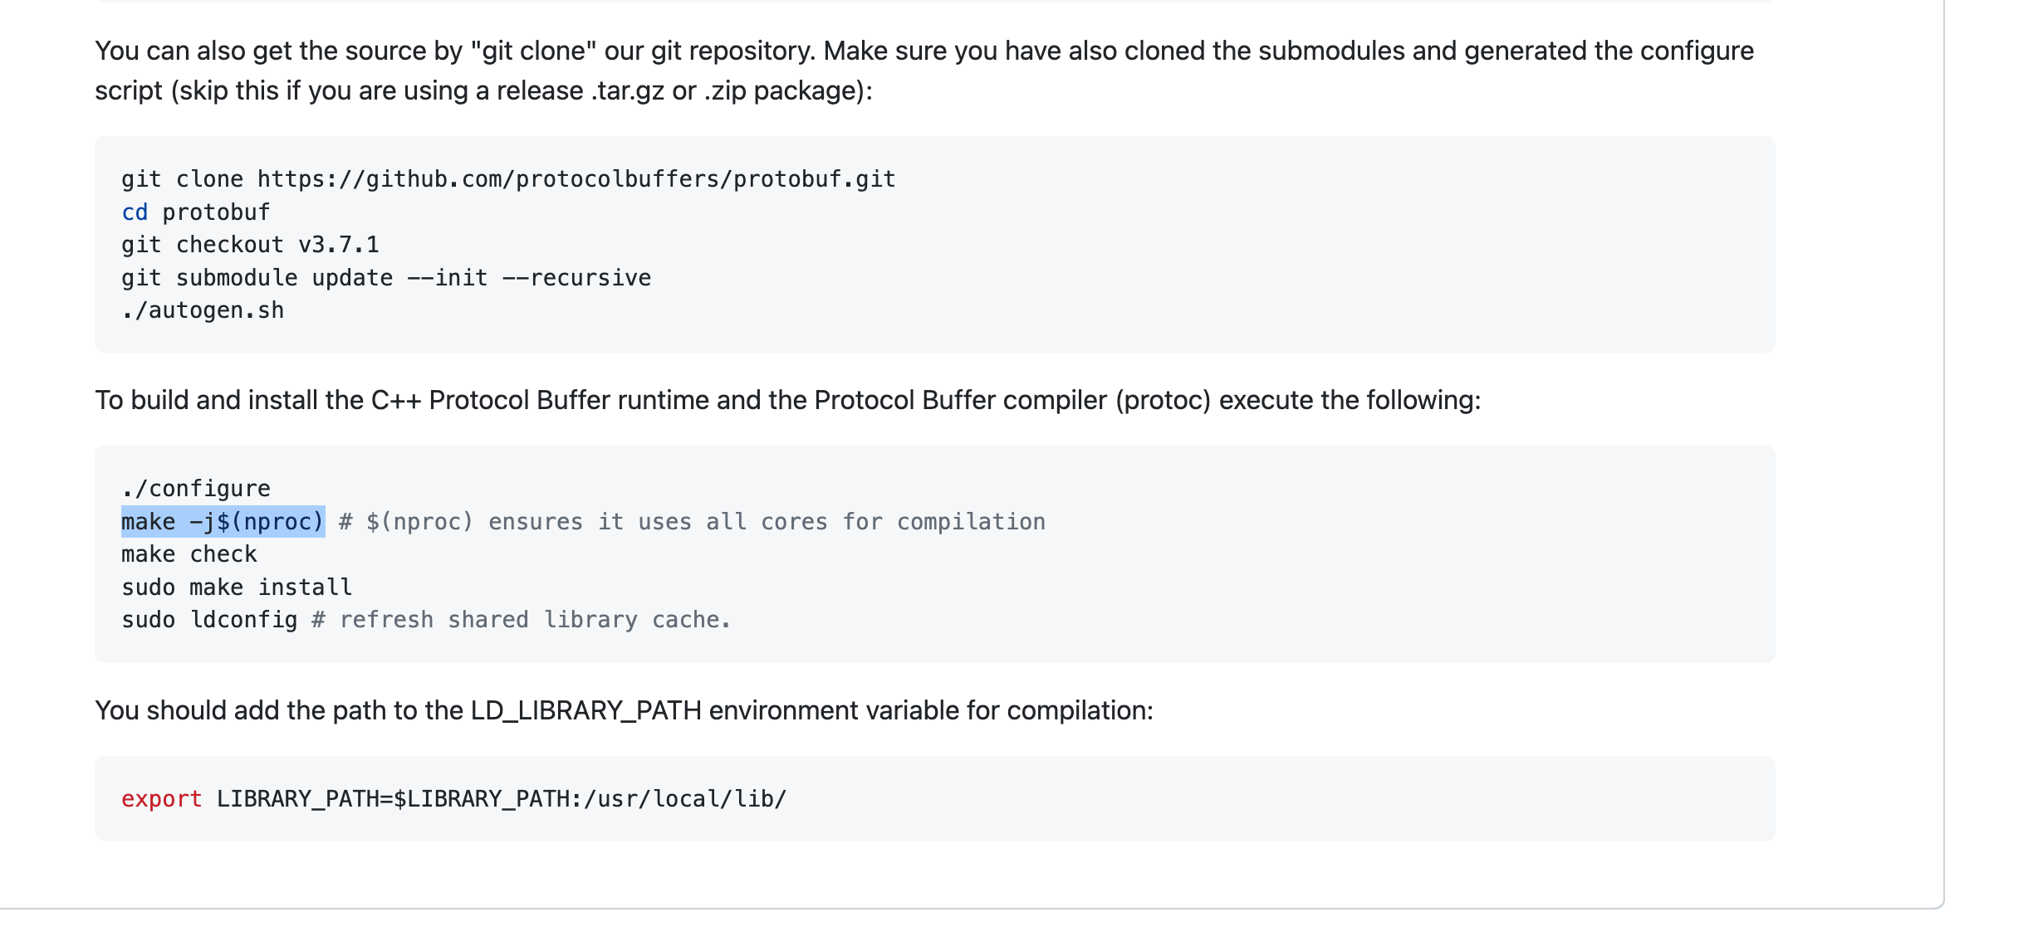

=========================

install suites:

<https://github.com/Safeheron/safeheron-crypto-suites-cpp>

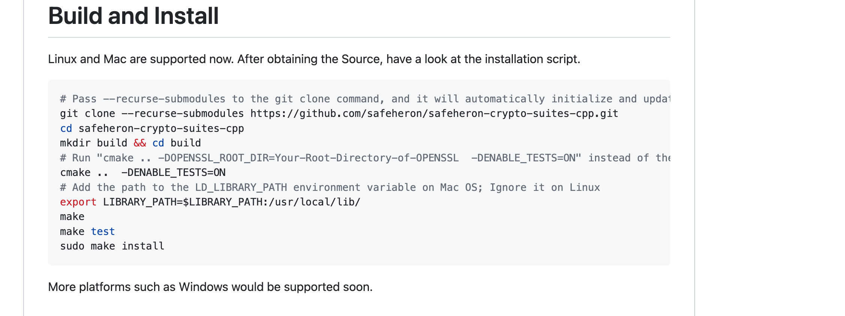

==============

<https://github.com/Safeheron/tss-rsa-cpp>

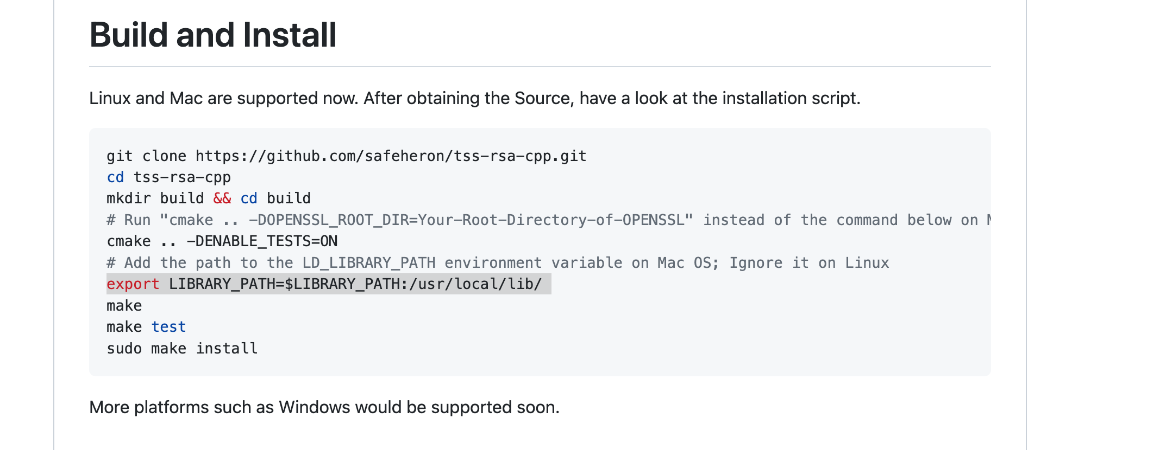

================

openssl的编译

cmake .. -DOPENSSL_ROOT_DIR=/opt/homebrew/opt/openssl@3 -DENABLE_TESTS=O

cmake .. -DOPENSSL_ROOT_DIR=/usr/local/opt/openssl@3/  -DENABLE_TESTS=O

cmake .. -DOPENSSL_ROOT_DIR=/opt/homebrew/opt/openssl@3 -DENABLE_TESTS=O